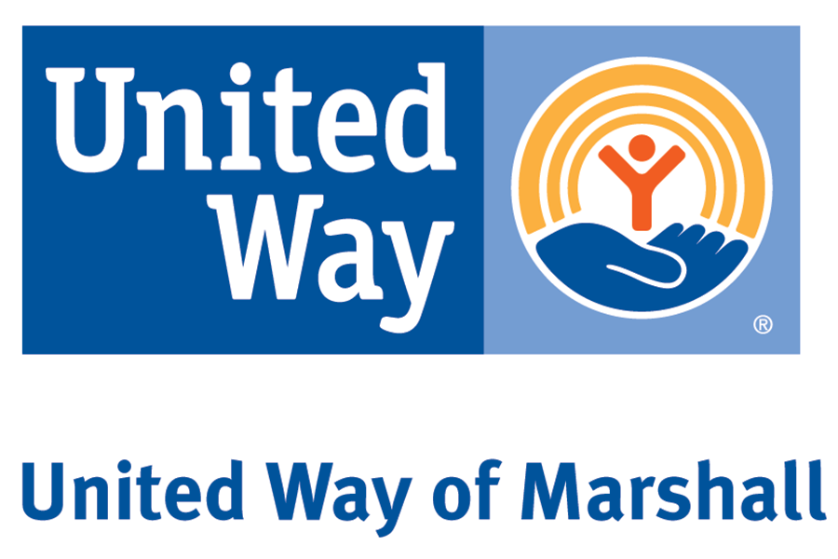
Date Received:_______

By:________________

ALLOCATION APPLICATION SUMMARY SHEET

Date of Application: ___________________

Legal name of organization applying: ___________________________________
(Should be same as on IRS determination letter & as supplied on IRS Form 990)

Year Founded: __________ Current Organization Budget $__________________

Address (Principal/Administrative):
_________________________________________________ _________________________________________________
_________________________________________________

Name & Title of Responsible Person:_________________________________________

Phone:________________Fax:_______________Email:_________________________
$

Amount requested from Marshall United Way for Current Year:

List any previous support from the Marshall United Way in the last three years:
______________________________________________________________________________________________________________________________________________________________________________________________________________________________________________________________________________________________________________________________________________________________________________________________________

List other funding sources (Requested and Received):
_____________________________________________________________________________________________________________________________________________________________________________________________

Purpose of Allocation (one sentence):
_____________________________________________________________________________________________________________________________

Geographic Area Served: _________________________________________________________

Impact/benefit: ________________________________________________________________

________________________________________ ________________
Signature, Responsible Person: Date:

________________________________________ _________________
Chairperson, Board of Directors Date:

